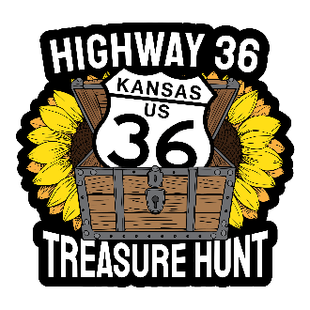
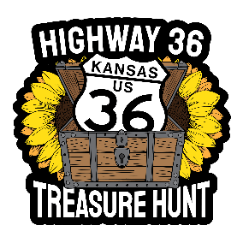
US 36 Annual Treasure Hunt

2026
County / Town Coordinators
REVISED August 2026
East to West

County Coordinator Email Address

Doniphan Theresa Rohrer: Theresa_rohrer@yahoo.com
Wathena – Troy – Highlands

Brown Hiwatha Chamber hiawathacoc@gmail.com
Robinson & Hiawatha

Nemaha Seneca Chamber kylee@comeseeseneca.com
Kylee does both : Seneca & Baileyville
Sabetha Chamber sabethachamber@gmail.com

Marshall One Marysville wayne@onemarysville.com

Washington Washington (town) rkern@washingtoncountyks.gov

Republic Belleville Chamber bellevilleccms@gmail.com

Scandia – Nick Levendofsky nick.levendofsky@gmail.com

Jewell Mankato director@jewellcountykansas.com

Smith CVB Office smithcountycvb@gmail.com
Lebanon & Smith Center

Phillips CVB/ Chamber Office cvbcham@ruraltel.net
Agra – Phillipsburg- Prairie View

Norton Norton Chamber nortoncc@discovernorton.com

Decatur Oberlin sdempewolf@oberlinkansas.gov
Norcatur – Matt Strevey zeikian@live.com

Rawlins City of Atwood cityclerk@atwoodks.com
McDonald judy@birdcity.com

Cheynne Saint Franics Director@ccdcks.org
Bird City judy@birdcity.com

